Strengthening IT Security: Analyzing and Securing Systems and Networks

Name: Oluwaseun Akinola

# Executive Summary

# In this project, I identified and addressed several key security issues within TechSecure Corp’s infrastructure. These included weak password policies, open file sharing, unnecessary services running on Windows Server, and a lack of network segmentation. I implemented strong password policies, restricted folder access based on user roles, hardened the Windows firewall, and applied critical updates to the server.

# On the Linux side, I secured SSH access by disabling root login and enforcing key-based authentication, and I corrected file permissions for sensitive system files like /etc/shadow.

# For the network infrastructure, I created VLANs for Admin, HR, IT, and Guest networks and configured Access Control Lists (ACLs) to restrict communication between departments. Ping tests confirmed that communication between VLANs was only allowed where required by policy.

# All security configurations were verified through testing and are documented with screenshots included in this report. Each screenshot is clearly labeled and shows both the configuration steps and the expected results (e.g., allowed/blocked ping attempts, ACL hits, firewall settings, etc.).

# Windows Server Hardening

To harden the Windows Server, I first configured strong password policies through the Local Security Policy. I enforced complexity requirements, set a 12-character minimum length, and limited login attempts to lock out after five failures.

**Password Policy Settings:**

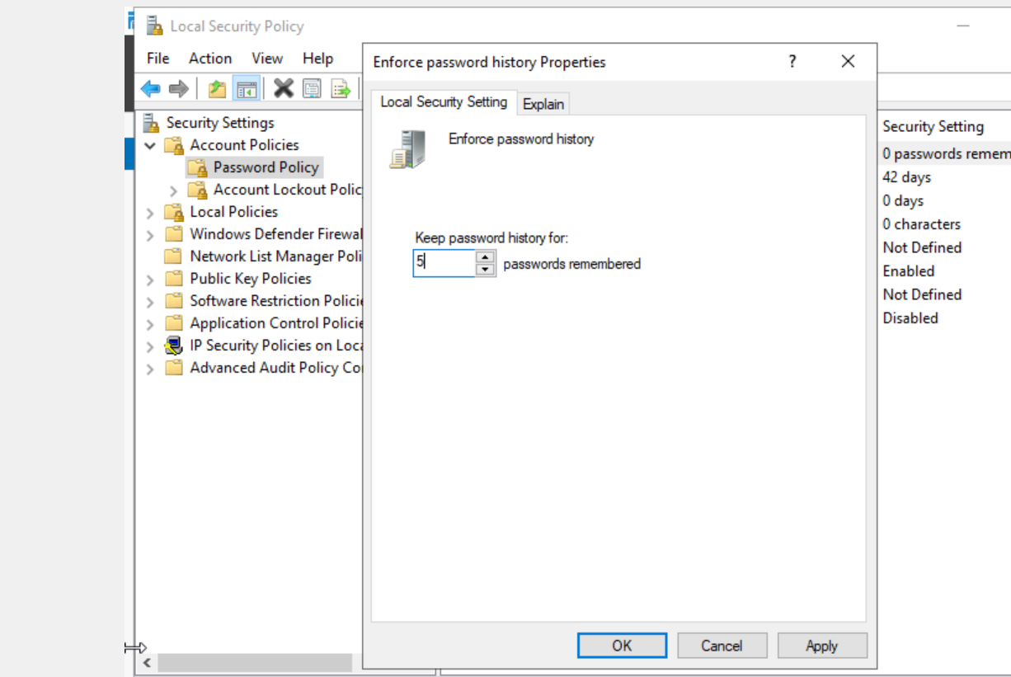

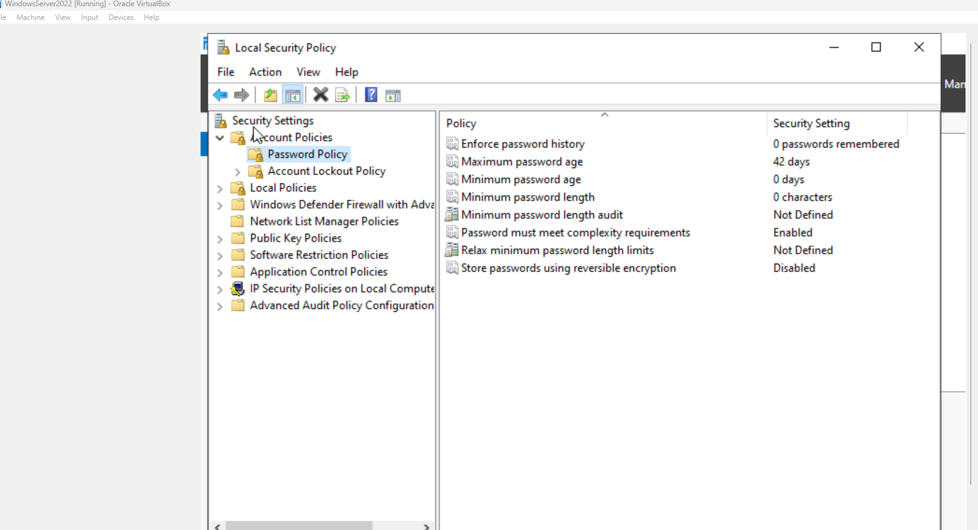

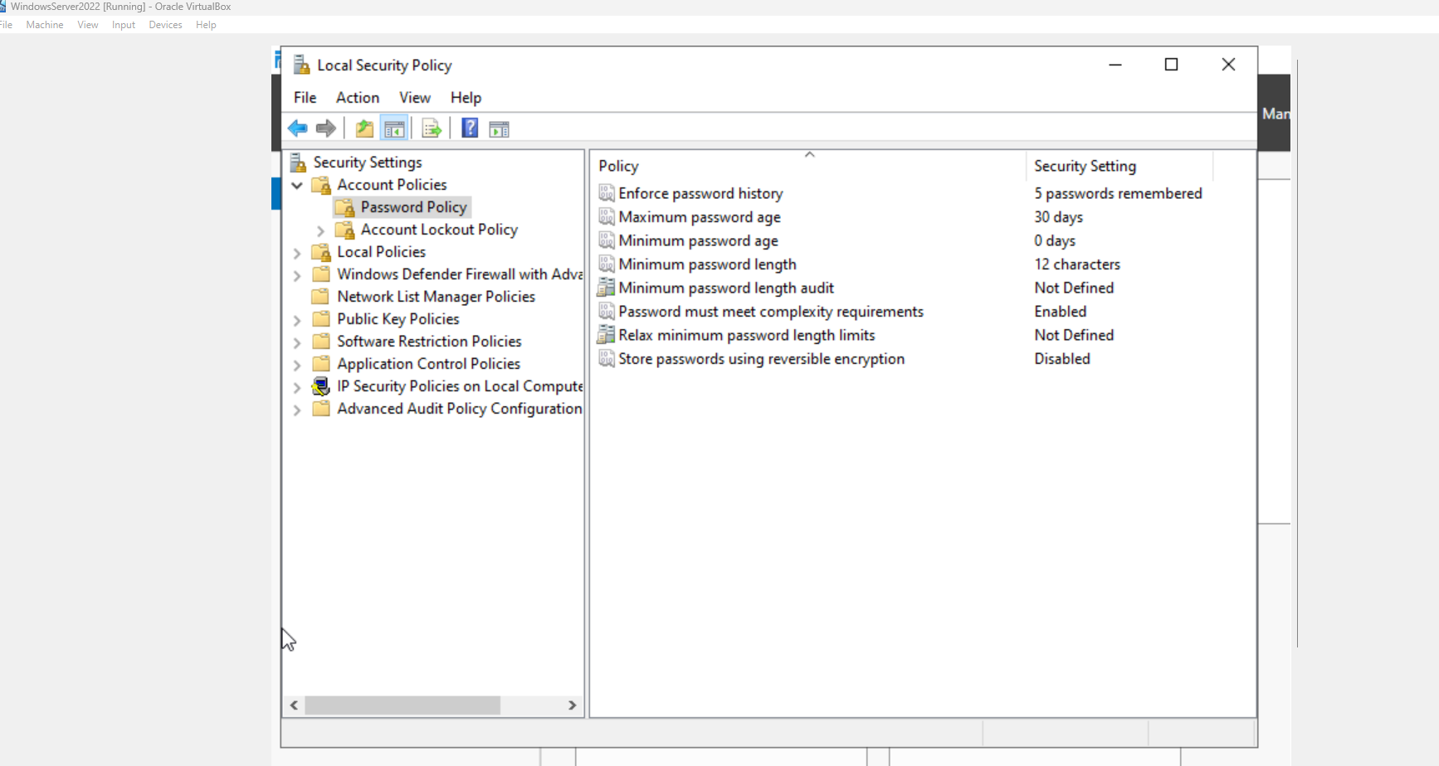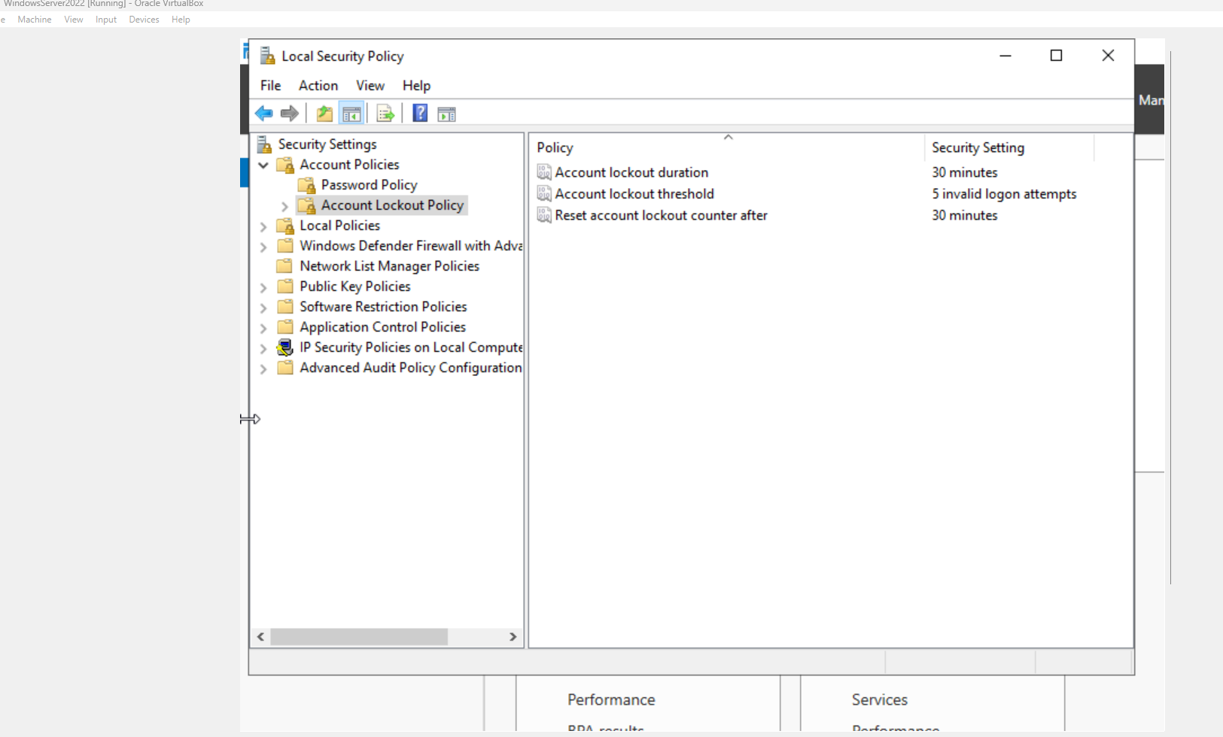

Next, I created a shared folder and adjusted both the sharing and NTFS permissions to remove the “Everyone” group and apply role-based access only to authorized users.

**Shared Folder Permissions:**

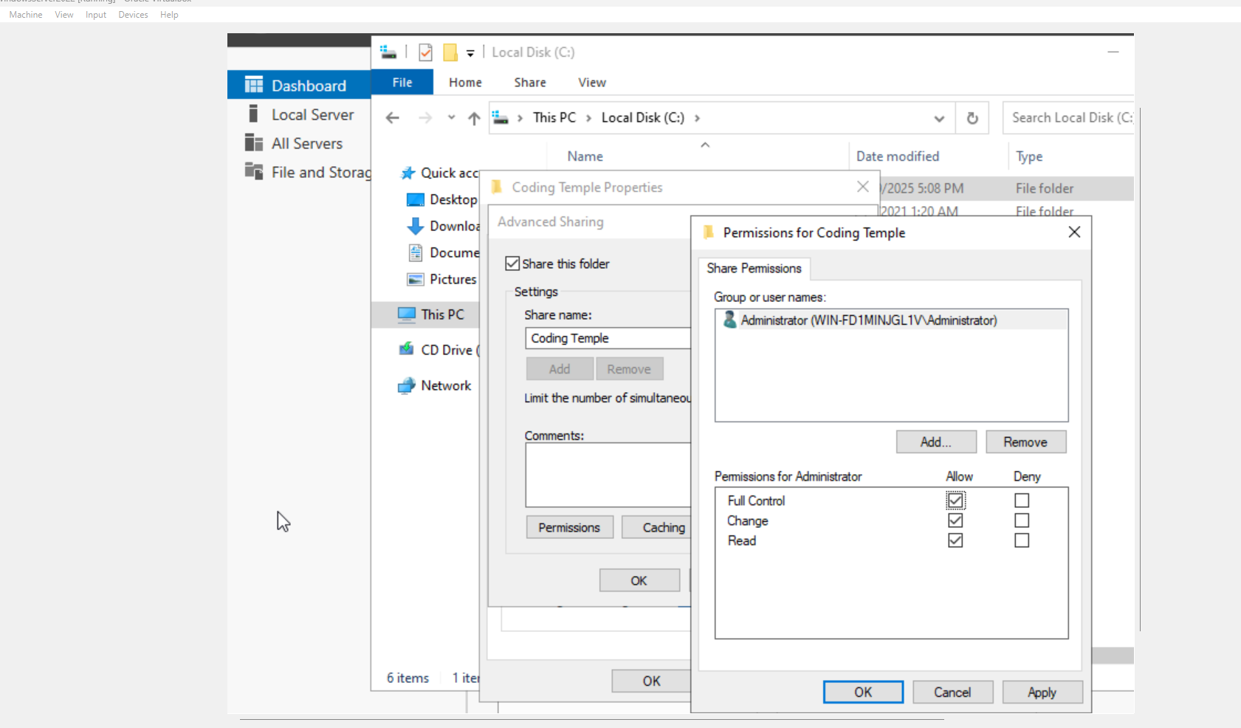

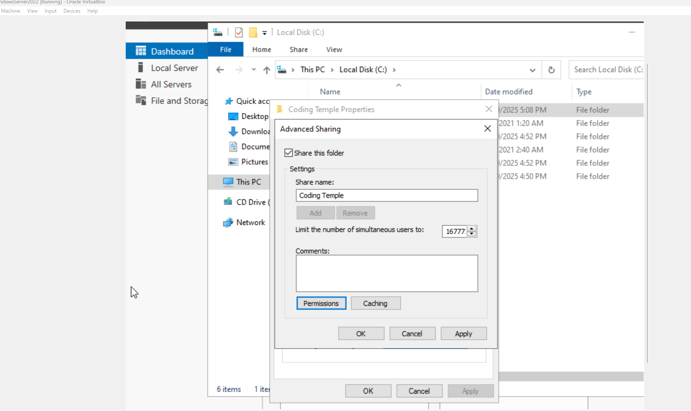

For firewall security, I enabled inbound rules for Remote Desktop (TCP 3389) and created a custom rule to allow HTTPS traffic on port 443. I confirmed the rules were active using both PowerShell and netsh commands, with screenshots included for verification.

**Windows Firewall Rules:**

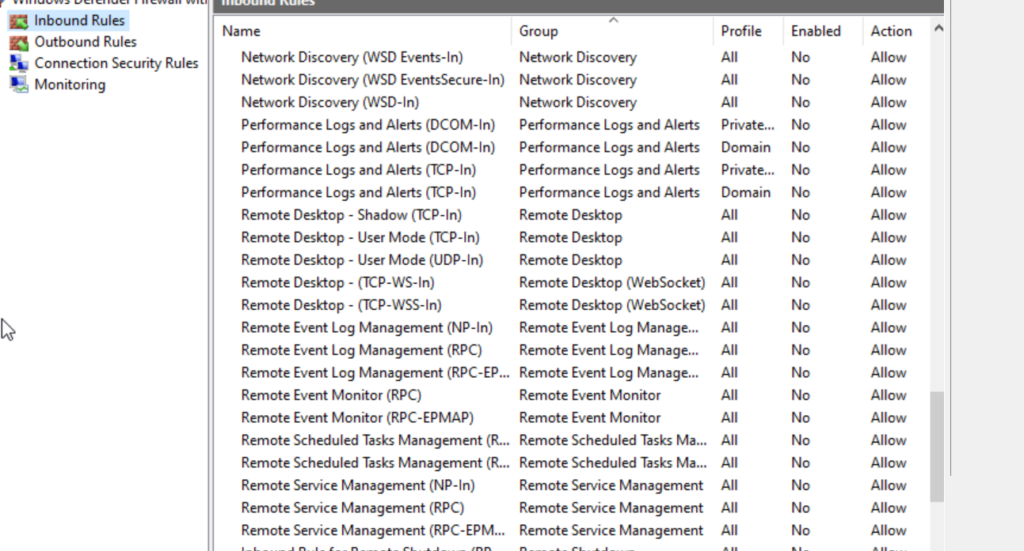

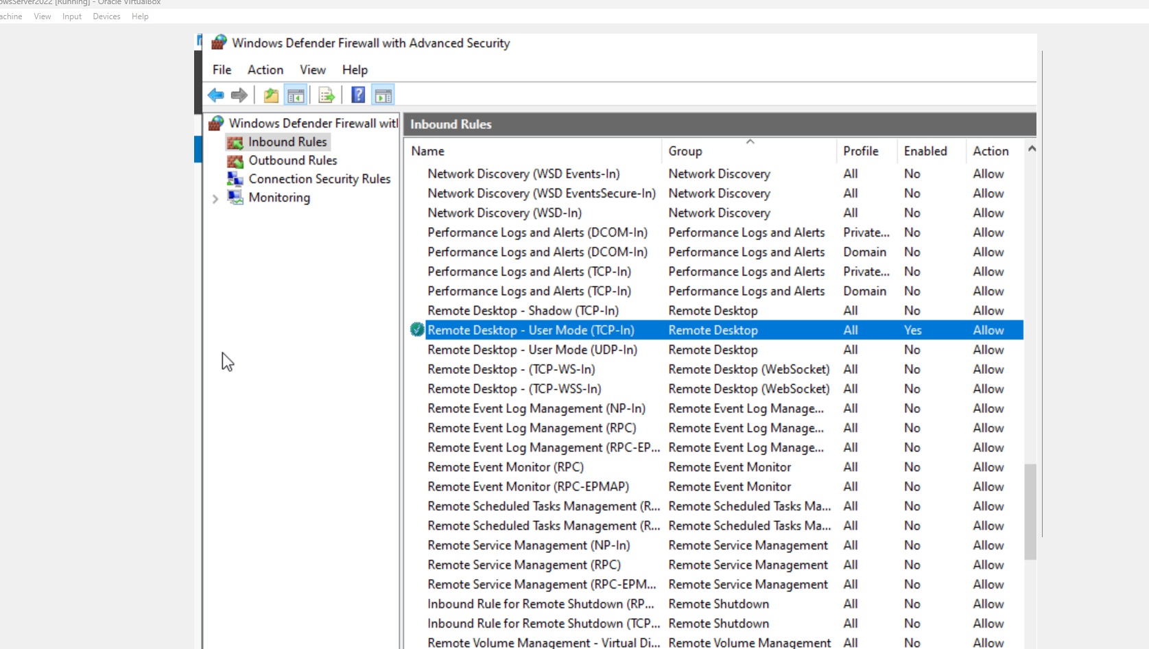

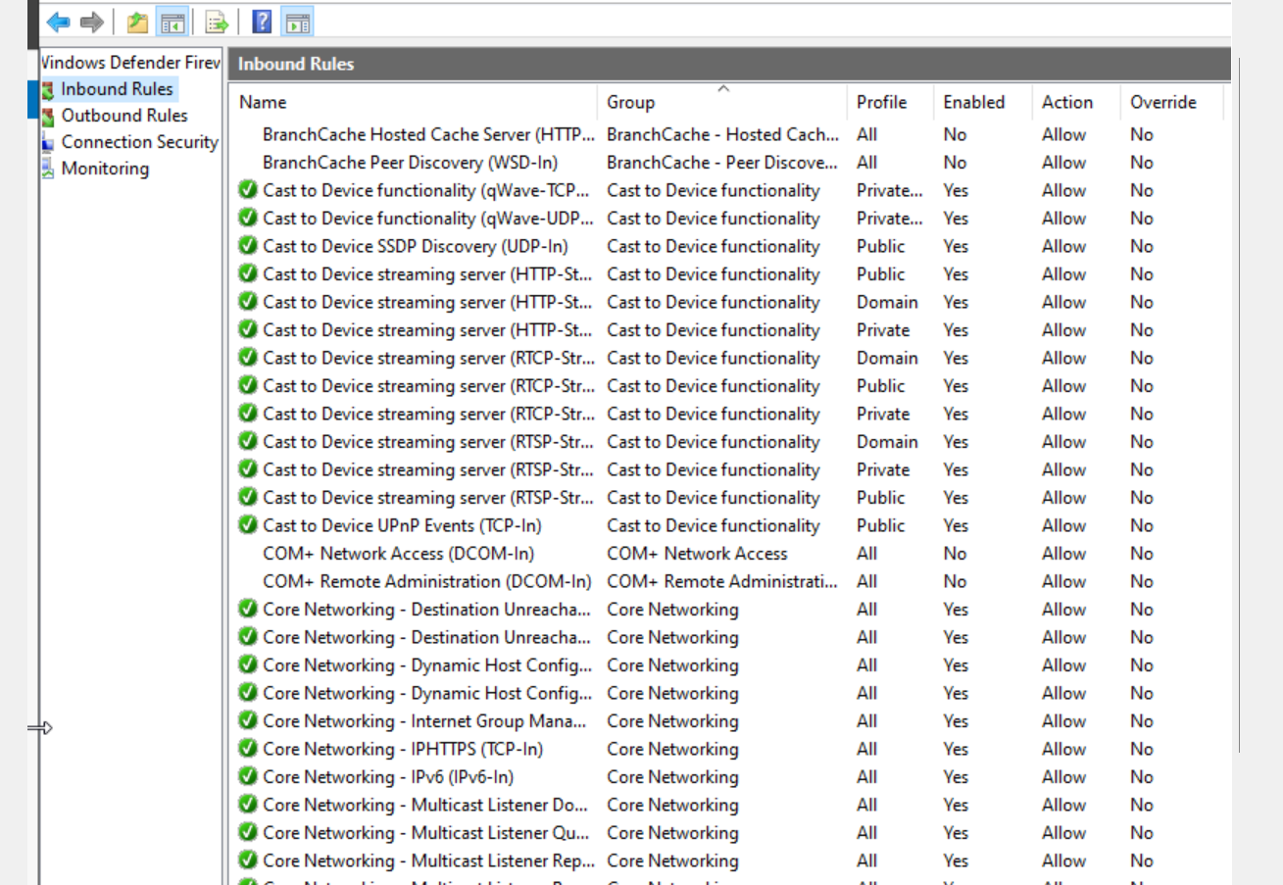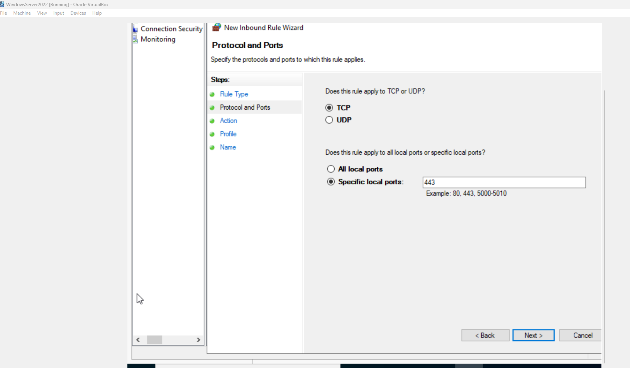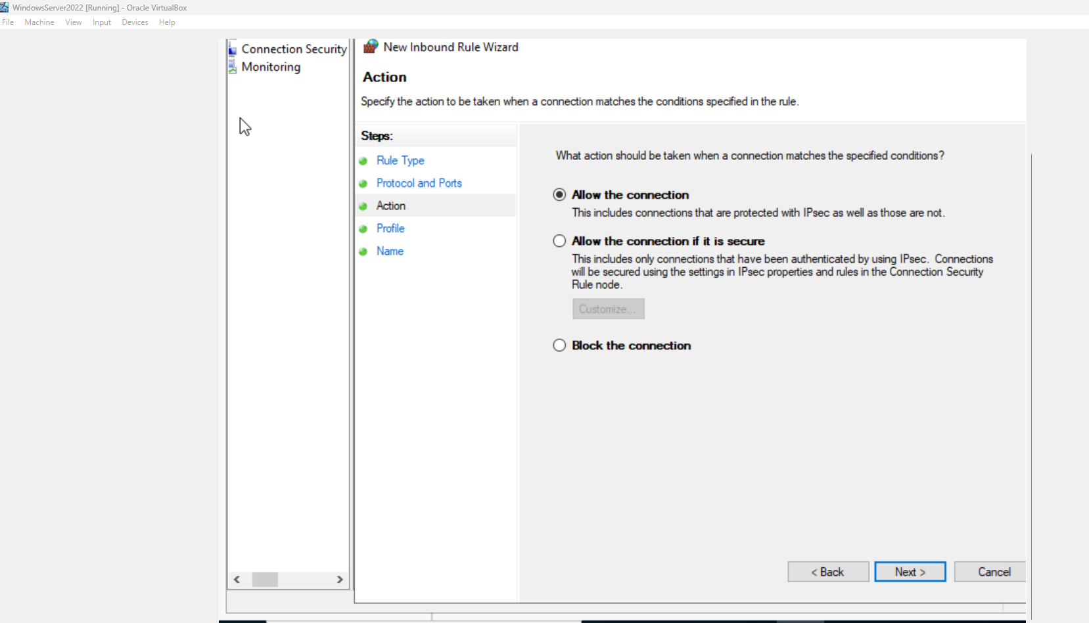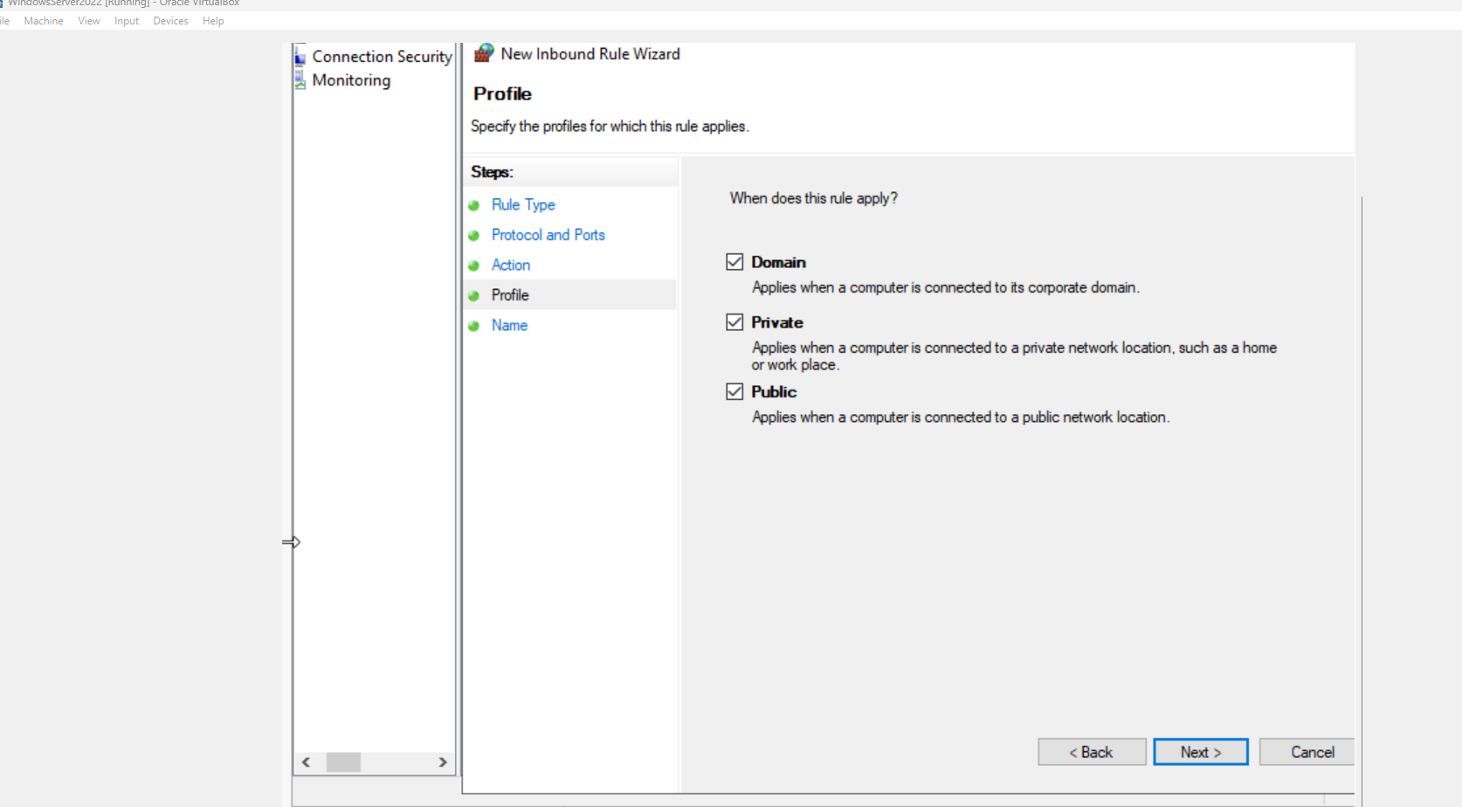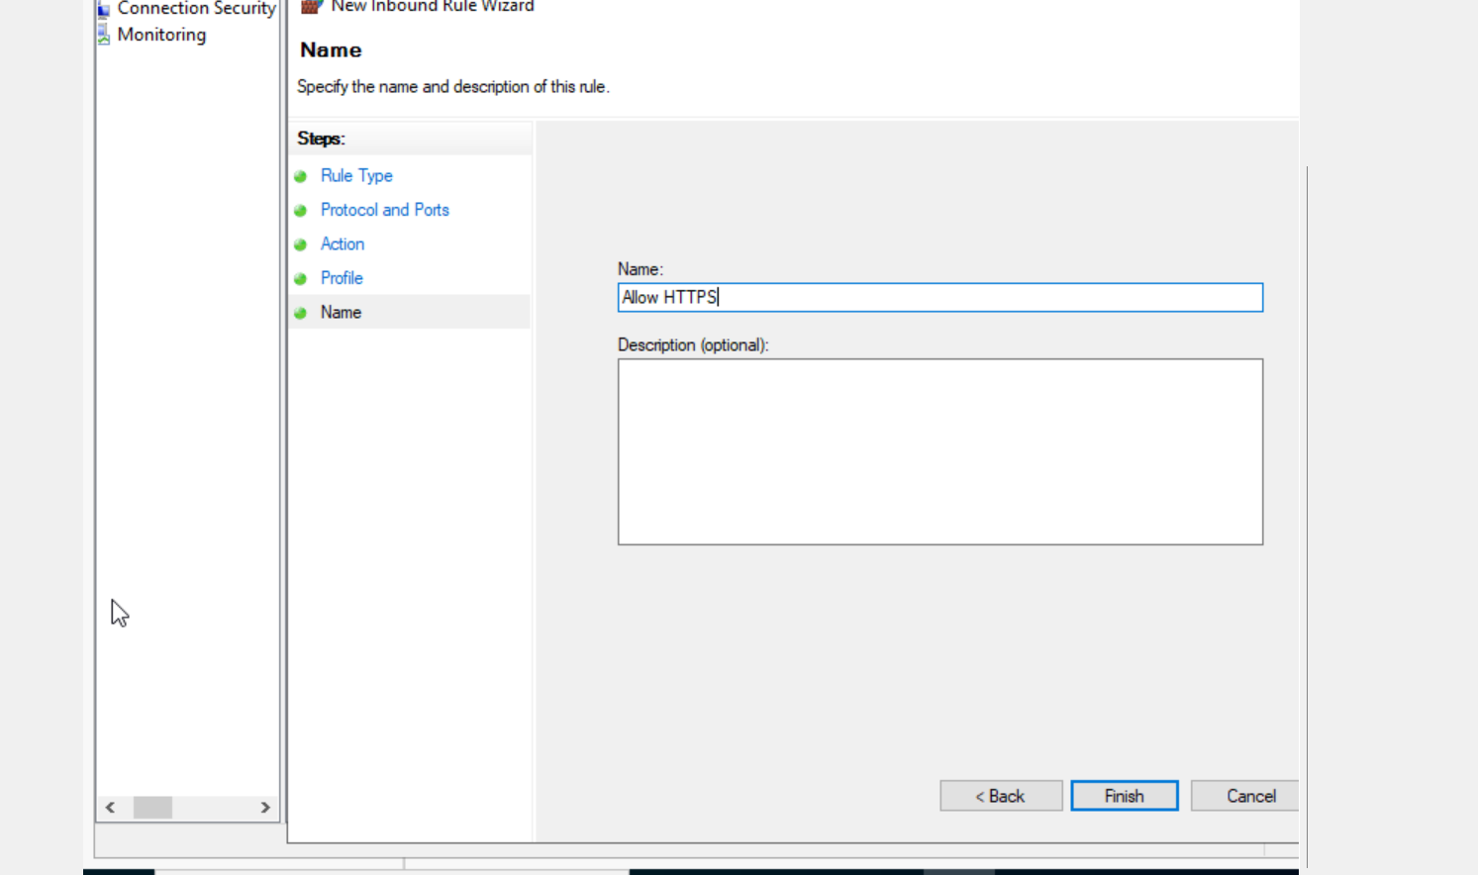

**PowerShell Output**

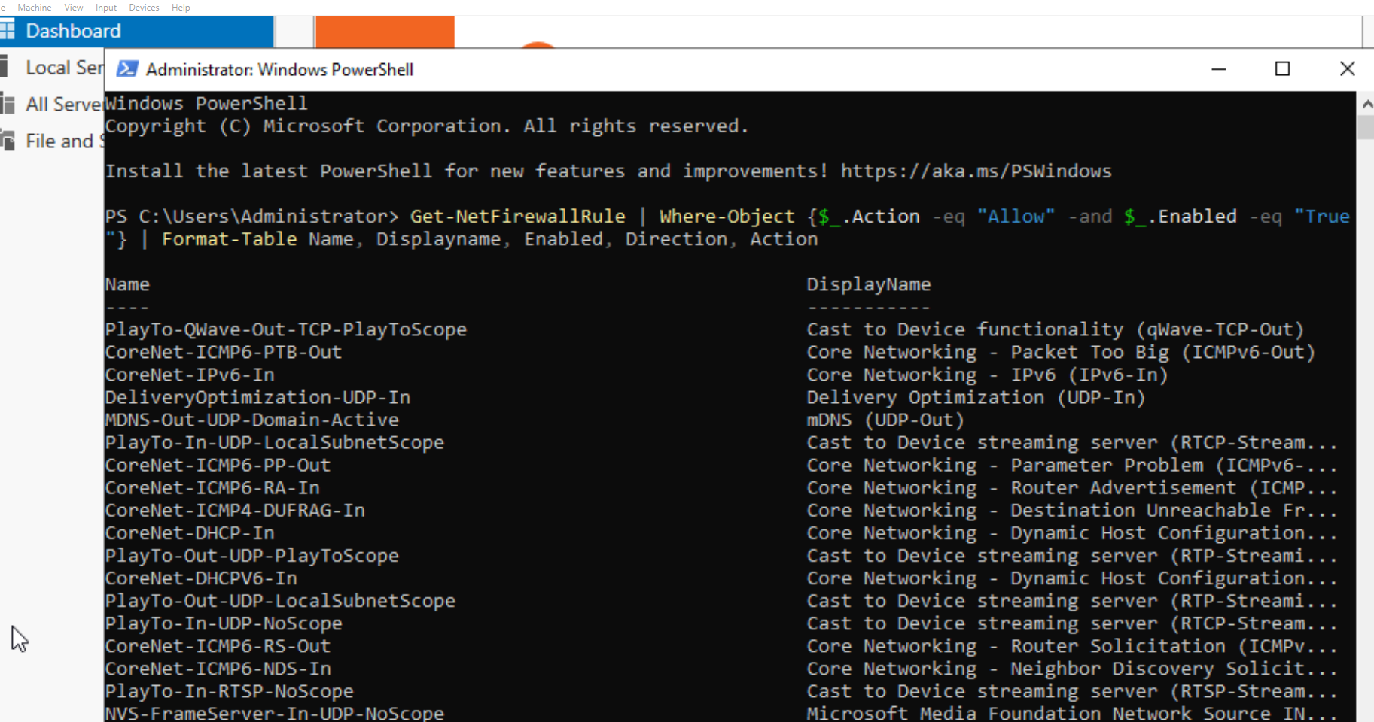

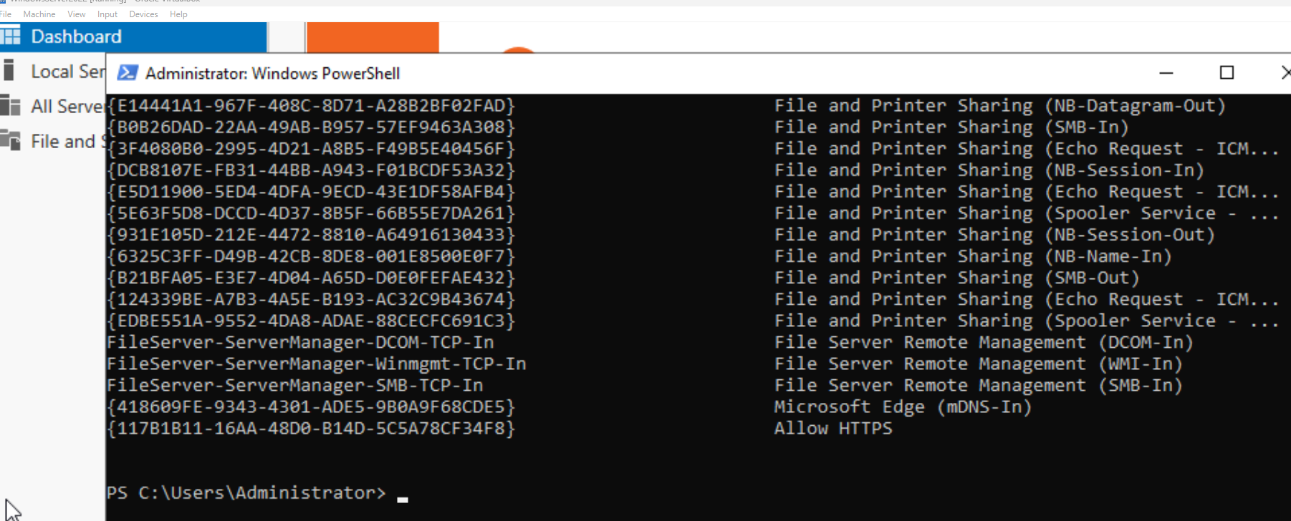

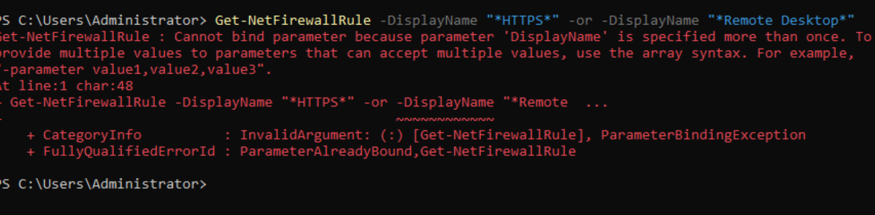

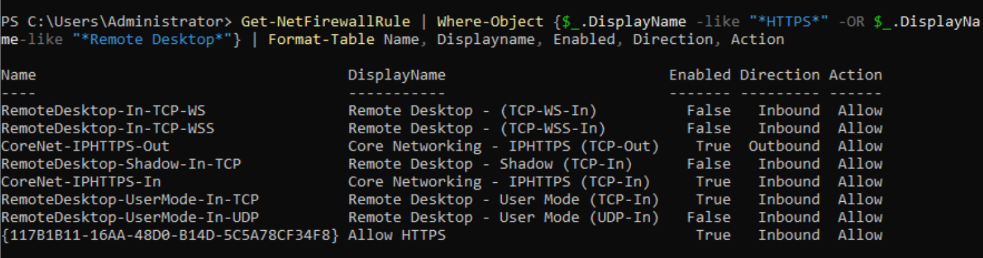

Lastly, I ran Windows Update to install the latest patches and captured the update history to confirm the system is current and protected against known vulnerabilities.

**Windows Update:**

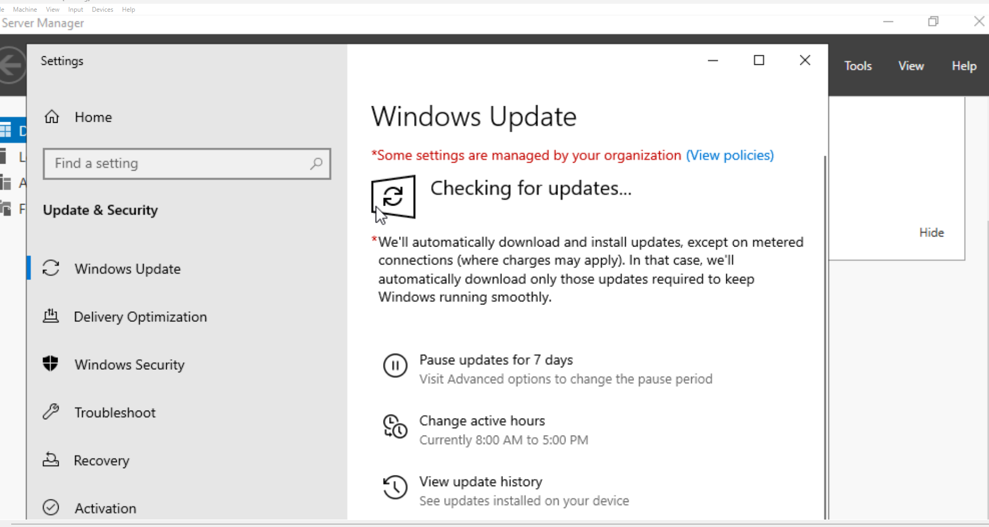

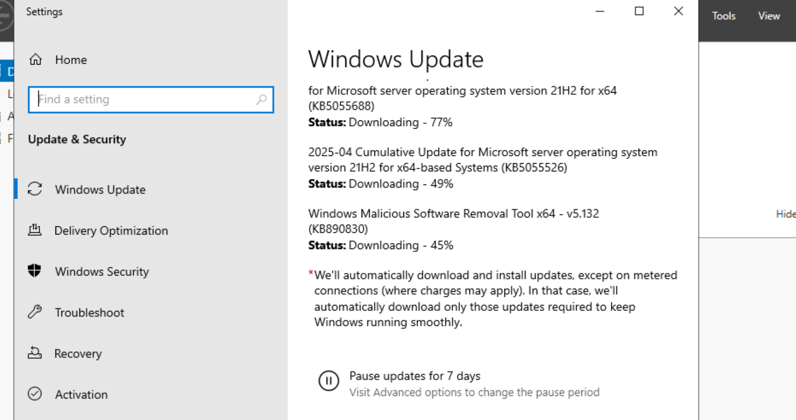

# 2. Linux Server Hardening

To improve the security of the Ubuntu server, I focused on hardening SSH access and correcting file permissions. First, I edited the /etc/ssh/sshd_config file to disable root login (PermitRootLogin no) and disable password-based authentication (PasswordAuthentication no). This ensures that only users with valid SSH keys can access the server remotely, and it prevents brute-force attempts against the root account.

Next, I verified the settings using a grep command and attempted to SSH into the server from my host machine. As expected, the connection was denied due to the lack of a valid SSH key, confirming that key-based authentication is enforced.

Finally, I checked the permissions on /etc/shadow, a sensitive file that stores hashed passwords. Using the ls -l command, I confirmed that the file is only readable by root and the shadow group, which is the correct and secure setting.

These steps help reduce the attack surface and protect against unauthorized access and privilege escalation.

**SSH Configuration:**

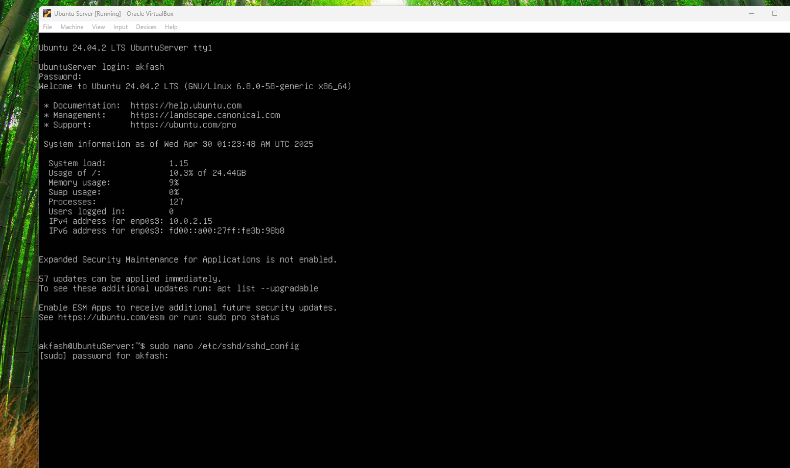

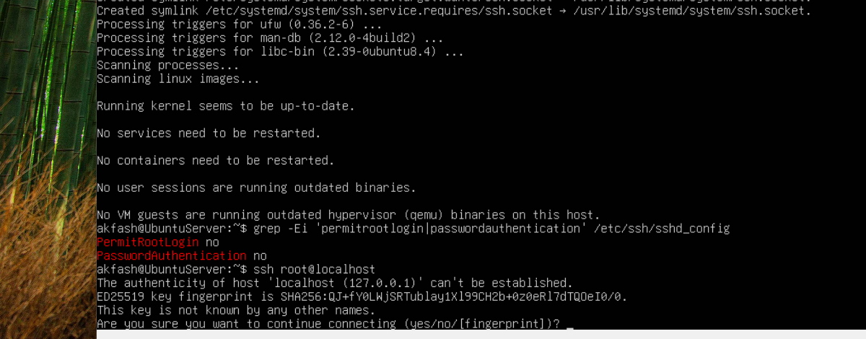

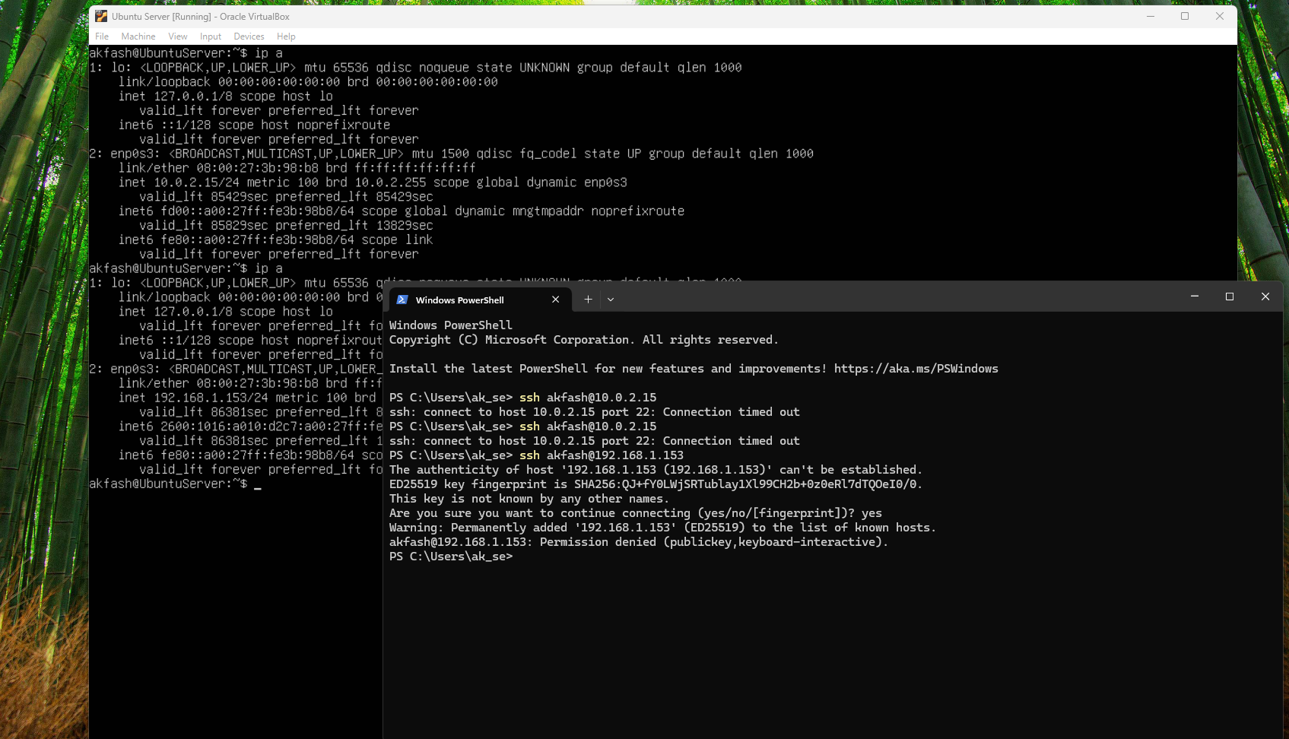

**/etc/shadow permissions**

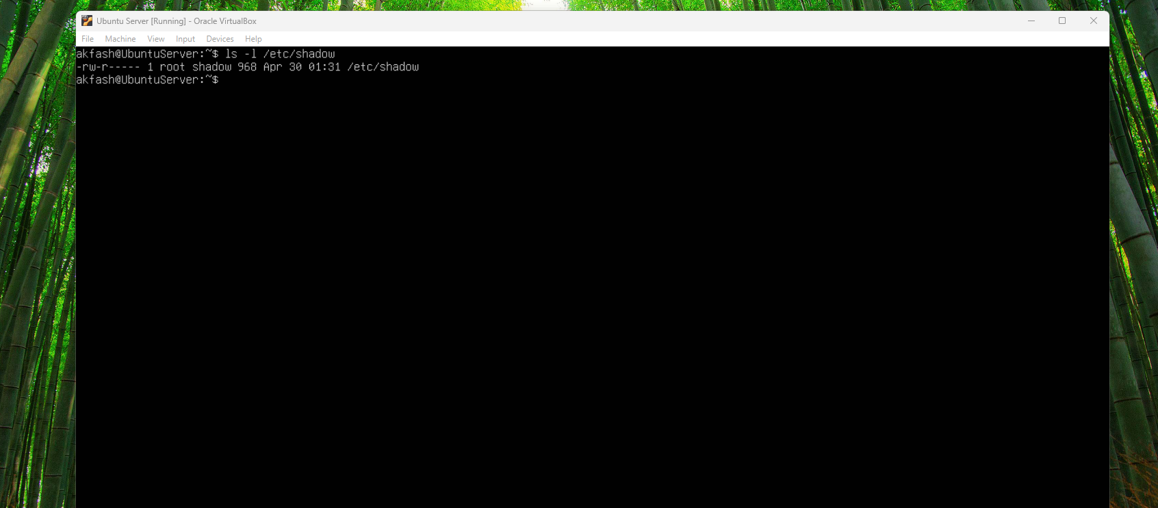

# 3. Network Security with VLANs and ACLs

For this project, I set up a network using VLANs and ACLs to make it more secure and organized.

**VLAN Setup**

I created four VLANs to separate traffic based on department:

Admin (VLAN 10)

HR (VLAN 20)

IT (VLAN 30)

Guest (VLAN 40)

Each VLAN was assigned to specific switch ports for each PC, and I configured a trunk port to allow all VLAN traffic to go through the router. I used a router-on-a-stick setup, which means I created subinterfaces on the router for each VLAN so they could communicate through the router if allowed.

**ACLs (Access Control Lists)**

To control who can talk to who, I used ACLs:

ACL 100 was applied to the HR VLAN. It blocks HR from accessing Admin and IT, but still allows HR to communicate with Guest and other general traffic like internet access.

ACL 110 was applied to the Guest VLAN. It blocks Guest users from reaching any internal network (Admin, HR, or IT). This way, guests can only access the internet, and not sensitive parts of the network.

I applied these ACLs on the router interfaces so that the filtering happens as soon as the traffic hits the router.

**What This Solves**

Before this setup, all devices could talk to each other freely, which wasn’t secure. Now:

Admin can reach HR and IT.

HR can’t reach Admin or IT.

Guest users can’t reach anyone inside the network.

This setup helps reduce risks like lateral attacks and keeps each department’s traffic more secure and separated — while still allowing the right people to connect when needed.

**Topology Diagram:**

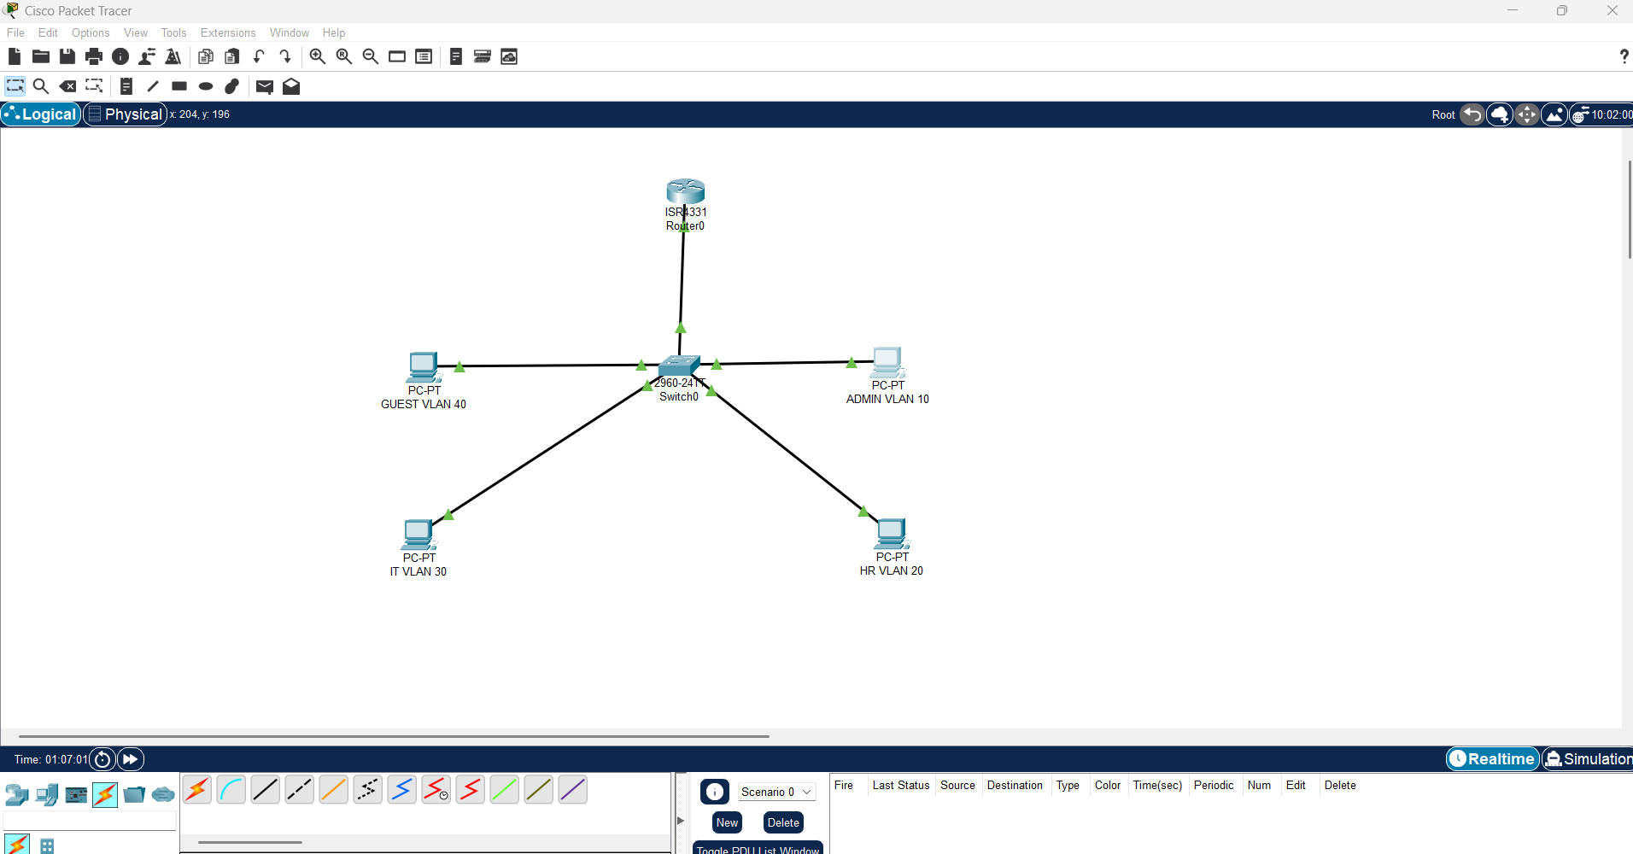

**VLAN Configuration Summary**

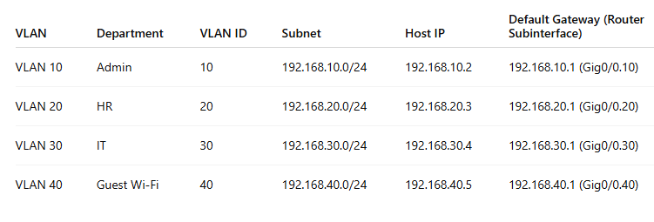

**Show vlan brief:**

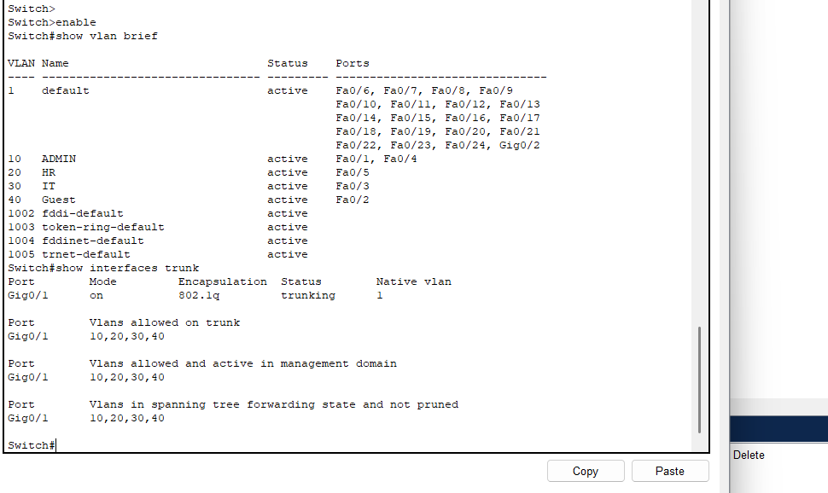

**Show access-lists/ip interface**

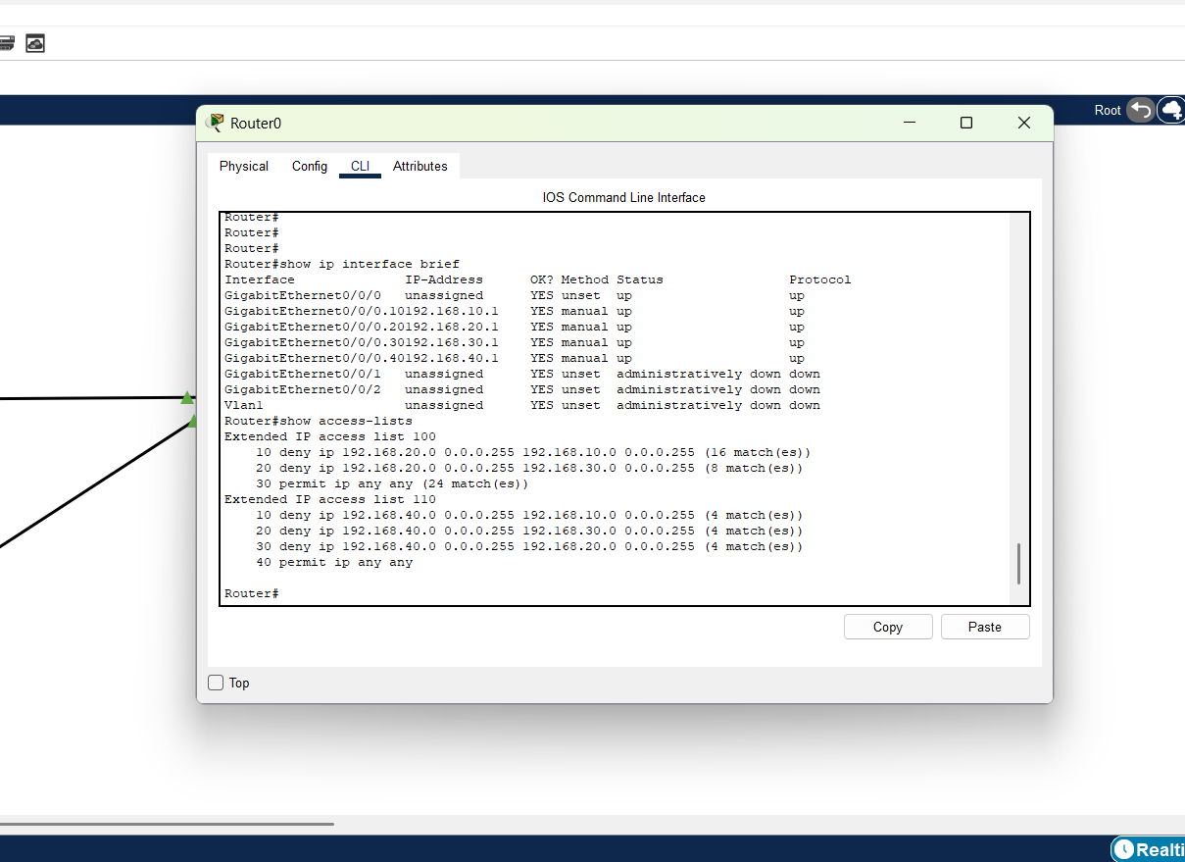

**Ping Tests**

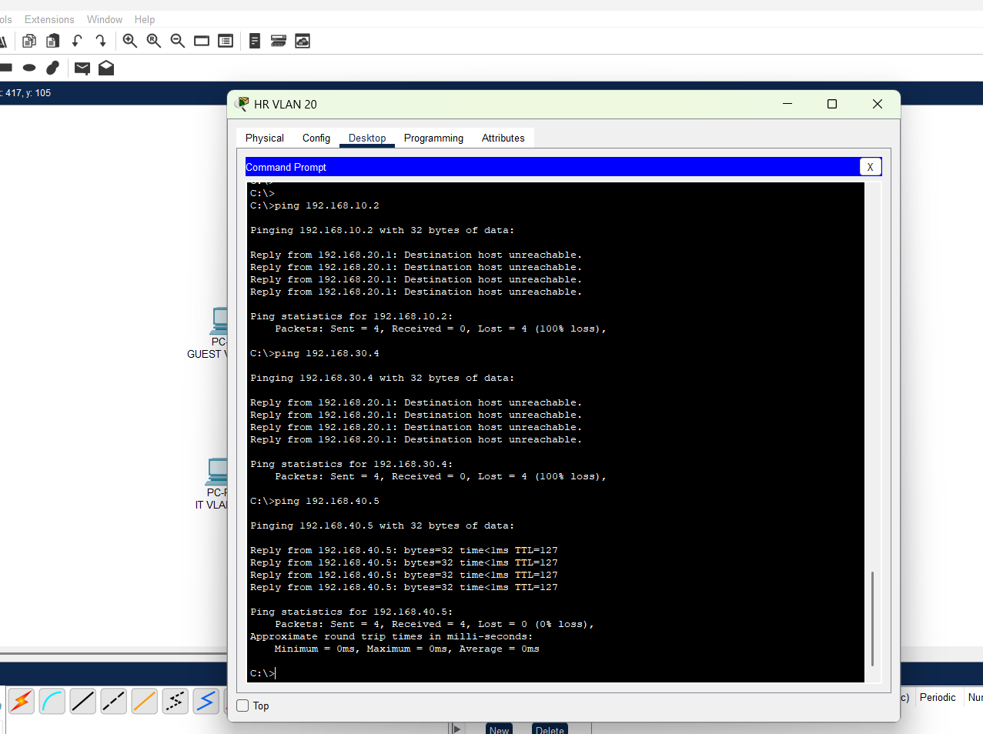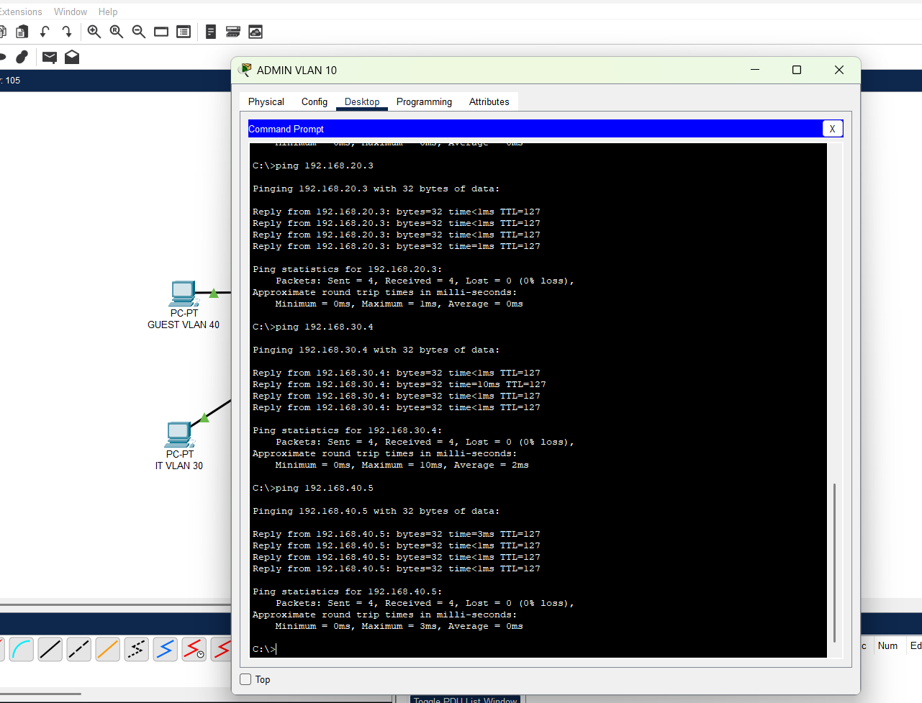

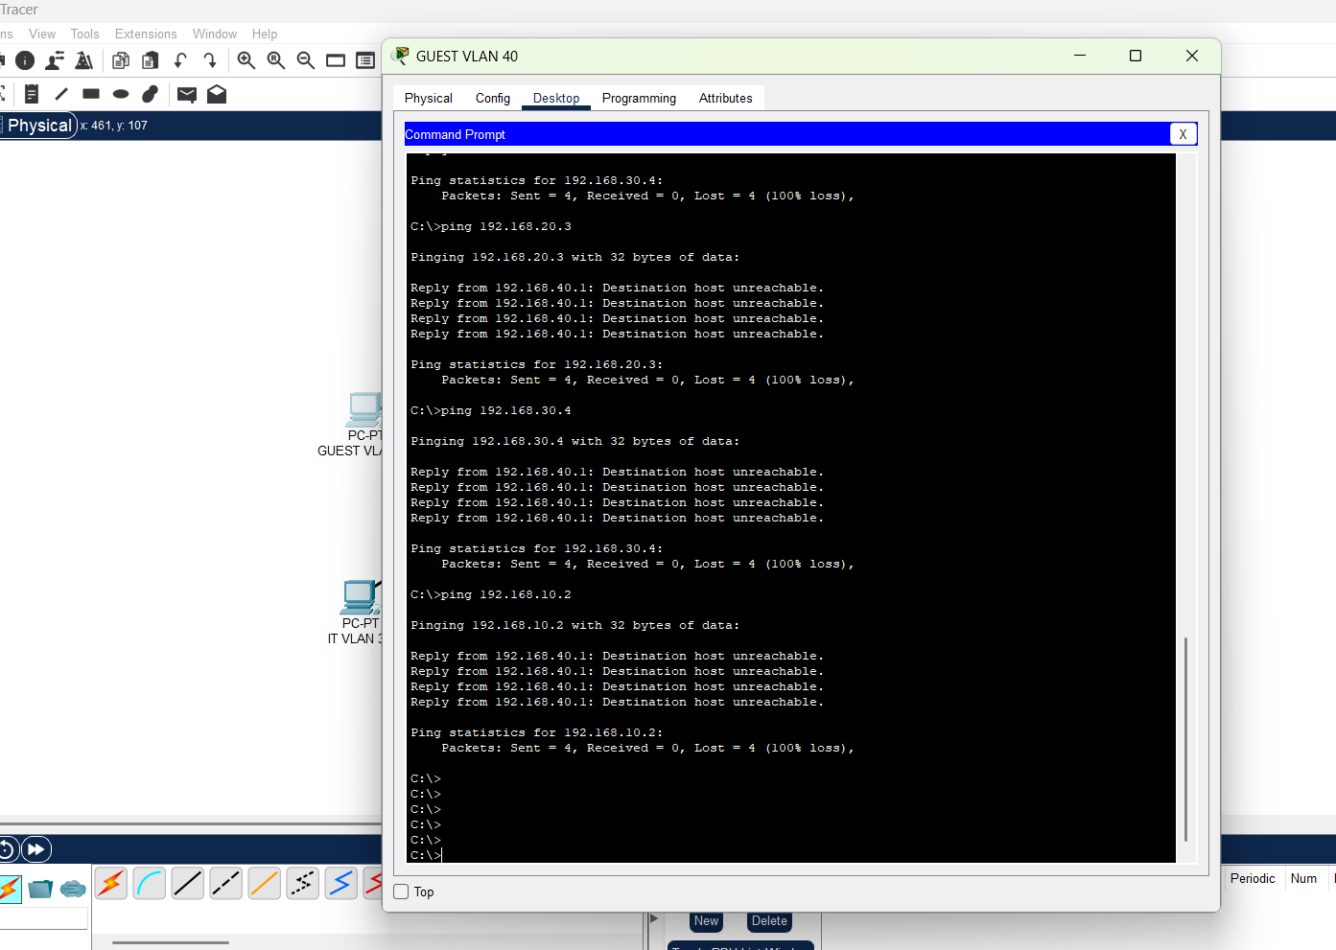

# 4. Lessons Learned

While completing this project, I developed practical skills in system hardening, access control configuration, and network segmentation. I gained confidence working with PowerShell, Linux terminal commands, and Cisco CLI for VLANs and ACLs. I also learned how to document changes effectively and validate security implementations using testing tools.

# 5. References

- Microsoft Docs: Group Policy Management and Windows Firewall

- Ubuntu Documentation: SSH and File Permissions

- Cisco Packet Tracer Labs and CLI Guides